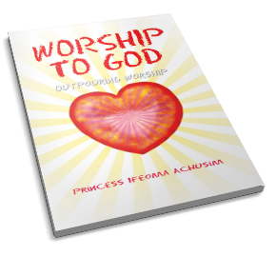
Exalting God through the power of the written word, author Princess Ifeoma Achusim shares twenty short yet meaningful poems that send messages of worship and glory. WORSHIP TO GOD talks of the effect of the Word of God in the life of a believer, the fruits of the Spirit, communication with God, and more. After each poem, the author provides a commentary, explaining the poem’s significance, including the time, place, and her inspiration for writing it.
Paired with moving illustrations that uplift the heart, enlighten the mind, and refresh the soul, WORSHIP TO GOD is also a loving invitation to give thanks to the Almighty through prayers and exaltation.
Available through local bookstore’s order desk or at these online bookstores: Amazon.com, Barnesandnobles.com, Xlibris.com, outpouring worship.com or by phone at 1-888-795-4274 ext.7879.

